Keep Blackstone Valley Beautiful
RI Affiliate of Keep America Beautiful

FOR IMMEDIATE RELEASE

September 10, 2018

Donna Kaehler
KBVB Coordinator
401-724-2200

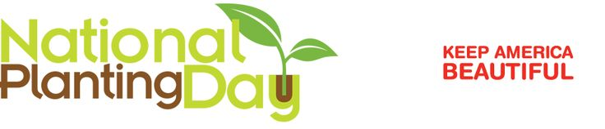
Pawtucket, RI -- Keep Blackstone Valley Beautiful (KBVB) is celebrating National Planting Day, a fall initiative of Keep America Beautiful, by encouraging residents to beautify our communities with planting bulbs this fall.

KBVB has organized a fundraiser with Dutch Mill Bulbs, a company offering a variety of tulips, daffodils, irises, blue bells and mixed assortments bulbs. Bulbs are a wonderful option that gardeners plant in the fall, water and then come Spring, enjoy all the beautiful flowers that come up year after year.

To support KBVB with this fundraiser, gardeners can order directly on-line through Dutch Mill Bulbs with the link below, or to avoid shipping costs, place your order by visiting us at the Blackstone Valley Visitor Center, 175 Main Street Pawtucket RI. Orders must be placed by October 5th for Fall planting in our RI climate.

Dutch Mill shares the sales 50/50 with KBVB allowing us to support our yearly programs that end litter with Great America Cleanups events, recycling education, and programs that make our communities a cleaner, greener and more beautiful places to live.

Those willing to come out and get dirty, KBVB is looking for volunteers to join our Planting Day Friday September 28, 2018 from 10 am – 12 noon. Volunteers will help plant bulbs under the 180 cherry trees that line Roosevelt Avenue, our living park in Central Falls and Pawtucket.

KBVB is also looking for residents to Adopt- A-Cherry Tree and help care for the trees by weeding, watering and removing litter throughout the year. These small steps help improve the health of each tree, while offering an attractive environment for all residents and visitors to enjoy every day.
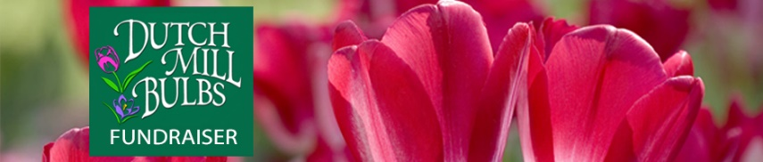
(click above)

For additional information visit our website at KeepBlackstoneValleyBeautiful.com or contact Donna Kaehler (401) 724-2200.

